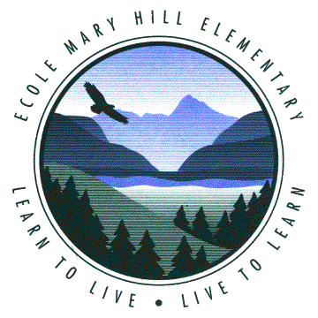
ÉCOLE MARY HILL ELEMENTARY SCHOOL
School District No. 43 (Coquitlam)
Telephone: 604-942-0264
1890 Humber Crescent
Port Coquitlam, B.C.
V3C 2V7

Dear Mary Hill Parents and Guardians,

We have two Kenyan students arriving in Canada on October 28th for two months. These students are connected with PA-MOJA (PA-MOJA.com), which is a Canadian charitable organization that links schools in Kenya with schools in North America for authentic cultural exchanges.
PA-MOJA’s secondary school cultural exchange initiative is a course called Butterfly Effect (ButterflyEffect.hoop.la). This is a course where students at schools in Canada Kenya research an inquiry question of their own personal interest and collaborate in an online environment to support each other’s learning(They will be attending Dr. Charles Best for this part of their stay). As well these students will be integrating into other schools in the district. These schools have paired with PA-MOJA to be a sister school to a school in Kenya. Mary Hill is a sister school to Mirera Primary School. We have been working with them for the past couple of years on cultural exchanges and students have been writing letters back and forth, creating videos and sending artwork as well.
The Coquitlam School District and PA-MOJA have partnered to bring Denis Chege and Allan Waithira to Canada. Both students have been involved with Butterfly Effect for over a year and have earned the trip to Canada from their hard work.
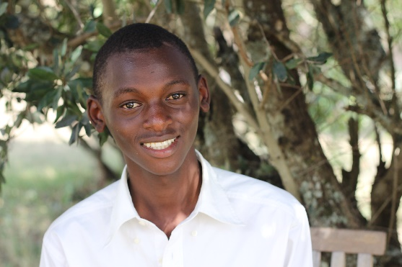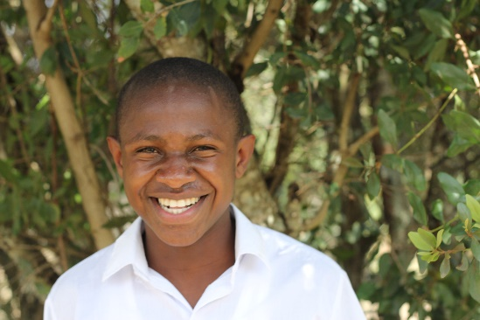
Denis Chege Allan Waithira

In order to set the students up for the lower-mainland fall/winter weather, to help raise some money to support the boys’ stay and to support the home-stay families we are asking for some donations.
Donations can be dropped off into the box in front of the office or contact Ms. Reid for more information on this.
We are hoping to receive the following:
1. Clothing and personal items for the boys. So if you have older sons please see if they would be willing to cull through their clothing to see if they have anything to donate.
- Allan is about 5’6 and Denis is about 5’8 and both would be either a small or medium shirt size. We are in need of clothing, particularly jeans, dress pants, t-shirts, dress shirts, sweaters, hoodies, rain jackets, winter jackets, toques and gloves/mitts.
- They have shoes sizes in the men’s 7-8.5 range. We are in need of runners, dress shoes and possibly even hiking type boots if anyone has any.
2. Any coupons for movies or things to do in Vancouver (ex. Aquarium) that you can donate, would be a big help to the homestay families.

Thank you for your support of the Kenyan students coming to Coquitlam and Mary Hill. We look forward to having them connect with as many students at the school as possible during their stay.

Sincerely,
Michele Reid
mreid@sd43.bc.ca

